Mission Carmel approved storm door

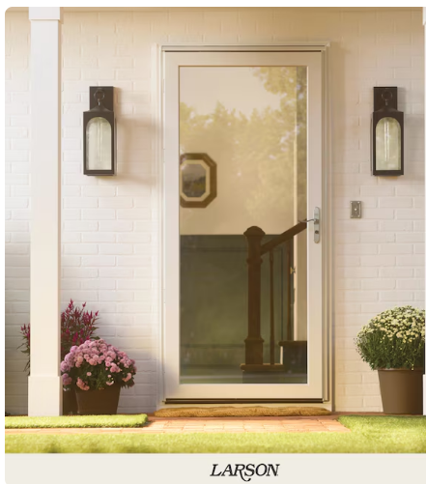

https://www.lowes.com/pd/LARSON-White-Linen-Full-view-Tempered-Storm-Door-Common-36-x-81-Actual-37-75-x-81-25/5000575741

